Lab Exercises 1 - Solutions
Python Basics, Decision Making and Object-Oriented Programming
These are indicative solutions for selected exercises from Lab Exercises - 1. They are not the only valid solutions. Python Basics - Selected Solutions
Exercise: Day-old Bread
Read the number of day-old loaves, calculate the regular price, discount and final total, and display money to two decimal places.
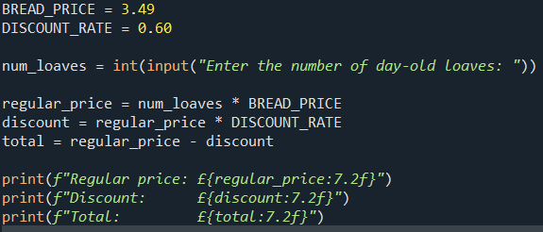

Exercise: Length and Slicing
Display the length of the entered text, then display the section between a user-supplied start and end index.
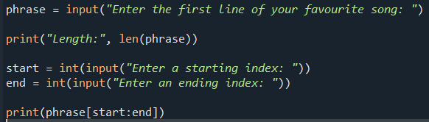

Exercise: Upper- or Lower-case Name
Use the first-name length to decide whether to join the surname and convert to upper case, or display the first name in lower case.
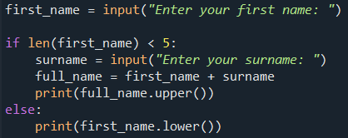
The condition checks whether the first name has fewer than five characters, then applies the required string operation.

Exercise: Pig Latin
Apply the simplified rule used in the practical: vowel-starting words gain 'way'; otherwise move the first letter to the end and add 'ay'.
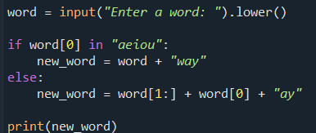

The first character is checked against the vowels; slicing word[1:] removes the first character when the consonant rule is used.

Decision Making - Selected Solutions
Exercise: Umbrella or No Umbrella
Use nested decisions and normalise user input with lower().
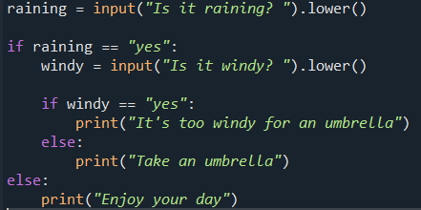
The second question is only asked when it is raining, so a nested if statement matches the structure of the problem.

Exercise: Even or Odd
Read an integer and use the remainder operator to classify it.
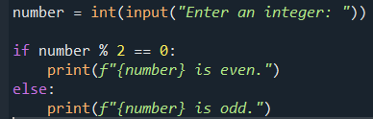

Exercise: Name the Shape
Map side counts from 3 to 10 to the required polygon names and reject unsupported values.
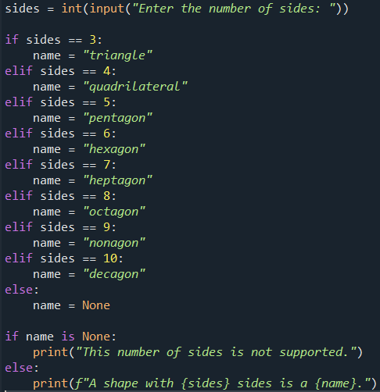

The if/elif chain selects exactly one supported polygon name; values outside 3-10 are handled by the final else.

Exercise: Classifying Triangles
For this exercise, assume the three side lengths form a valid triangle.
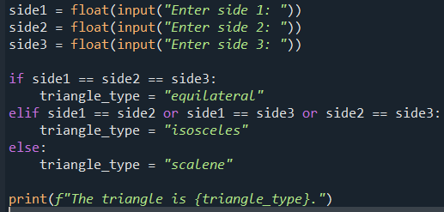
All three equal gives an equilateral triangle; otherwise, any pair equal gives an isosceles triangle; if no sides are equal it is scalene.

Object-Oriented Programming - Selected Solutions
Exercise: Create an Employee Class
Create a class with name and age instance attributes and then create two separate objects.
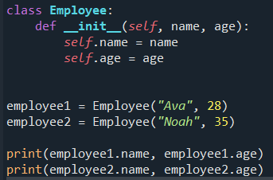

__init__() initialises the instance attributes for each object, so employee1 and employee2 can store different values.

Exercise: Add an Instance Method
Add introduce() so each Employee object can report its own data.
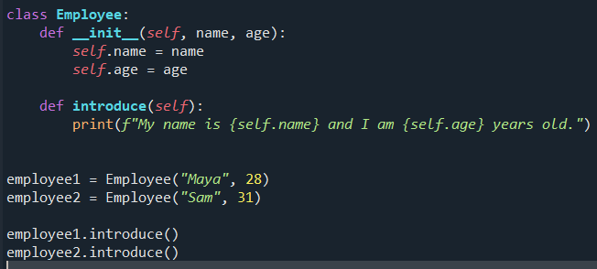
Remember that self refers to the current instance, allowing the method to use the correct name and age for whichever object calls it.

Exercise: Class and Instance Attributes
Use company as a class attribute and name as an instance attribute.
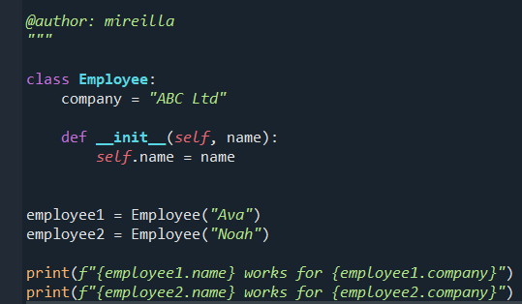

company is defined once on the class and is available through both objects, while each object has its own name.
Exercise: Inheritance: Employee and Manager
Create a Manager child class that reuses Employee behaviour and adds a new method.
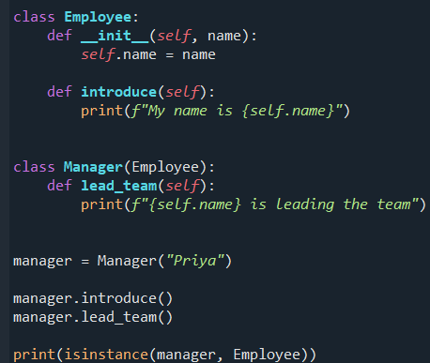

Manager inherits introduce() from Employee and adds lead_team(); isinstance(manager, Employee) returns True because Manager is a subclass of Employee.

Optional Integration Challenge - Indicative Solution
Exercise: Employee Training Eligibility
Combine instance attributes, a Boolean-returning method and decision-making.
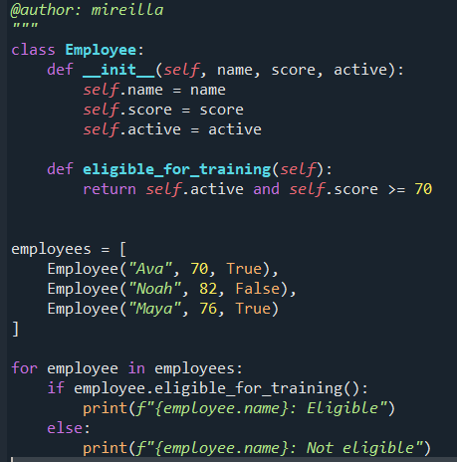
The method returns True only when both conditions are satisfied, and the calling code decides which message to display.

